|  |  |
| --- | --- |
| **As a** | new user of <https://FinTrust.com> |
| **I want** | to be able to register online |
| **So that** | I can myself create my login credential without waiting to receive my login credential via paper mail. |
| **Acceptance Criteria** | 1. On <https://FinTrust.com> , system shall display ‘Register’ hyperlink which shall be placed adjacent to the left of ‘Login’ hyperlink (refer Appendix 2: Display ‘Registration’ Link wireframe and Appendix 3: Data Table for ‘Registration’ Link) 2. On Click of ‘Register’ hyperlink, system shall navigate the user to ‘New User Registration’ page in the same browser window (refer Appendix 4: ‘New User Registration’ Wireframe and Appendix 5: ‘New User Registration’ Page Data Table) 3. System shall allow the user to enter registration data. 4. On Click on ‘Register’ command button, system shall perform the following validations:    1. All required data is entered    2. Email address is in a valid format    3. Email address is unique    4. Password entered is in a valid format    5. Re-entered password matches the password entered   4.1 In the event of passing of all the validations, system shall navigate the user to ‘Registration Complete’ page (refer Appendix 6: ‘Registration Complete’ Wireframe and Appendix 7: ‘Registration Complete’ Page Data Table)  4.2 In the event of failure of one or more validations, system shall display inline error messages. (refer Appendix 8: Inline Error Messages)  5. On Click of ‘Cancel’ command button, system shall discard the data entered by the user and shall navigate the user to home page (<https://FinTrust.com>) |

**Appendix 1:** ‘New User Registration’ Process Flow



**Appendix 2:** Display ‘Registration’ Link wireframe1

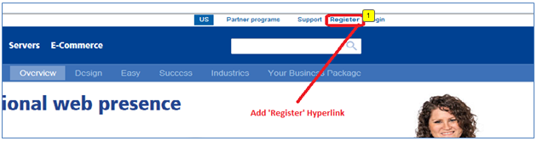

**Appendix 3:** Data Table for ‘Registration’ Link

|  |  |  |  |  |  |
| --- | --- | --- | --- | --- | --- |
| **ID** | **Field Name** | **Field Type** | **Content** | **Required Field?** | **Notes** |
| 1 | Register | Hyperlink | N/A | No | On click, navigate the user to ‘New User Registration’ page in the same browser window |

**Appendix 4:** ‘New User Registration’ Wireframe



**Appendix 5:**  ‘New User Registration’ Page Data Table

|  |  |  |  |  |  |
| --- | --- | --- | --- | --- | --- |
| **ID** | **Field Name** | **Field Type** | **Content** | **Required Field?** | **Notes** |
| 1 | New User Registration | Text | N/A | No | Page title |
| 2 | * are required fields | Text | N/A | No | Compulsory field |
| 3 | User ID | Text Box | Numeric | Yes | Min char: 6  Max char: 6 |
| 4 | Password | Text Box | Alpha Numeric | Yes | Data is encrypted  Min char: 8  Max char: 16 |
| 5 | Re-enter Password | Text Box | Alpha Numeric | Yes | Data is encrypted  Min char: 8  Max char: 16 |
| 6 | SSN | Textbox | Numeric | Yes | Data is encrypted  Min char: 9  Max char: 9 |
| 7 | Gender | Radio Button | Male, Female | No | No default selection |
| 8 | Security Question | Dropdown | 1) What is your pet’s name?  2) What is your best friend’s name?  3) What is your mother’s maiden name? | Yes | No default selection.  Sort the questions in alphabetical order |
| 9 | Security Answer | Text Box | Alpha Numeric | Yes | Min char: 2  Max char: 36 |
| 10 | Register | Command Button | N/A | N/A | On click, if all validations pass, navigate user to ‘Login’ page in same browser or else display inline error messages |
| 11 | Cancel | Command Button | N/A | N/A | On click, discard the data entered and navigate the user to home page |

**Appendix 6:** ‘Registration Complete’ Wireframe

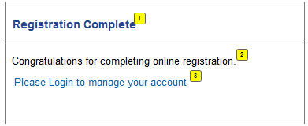

**Appendix 7:** ‘Registration Complete’ Page Data Table

|  |  |  |  |  |  |
| --- | --- | --- | --- | --- | --- |
| **ID** | **Field Name** | **Field Type** | **Content** | **Required Field?** | **Notes** |
| 1 | Registration Complete | Text | N/A | No | Page Title |
| 2 | Congratulations for completing online registration. | Text | N/A | No |  |
| 3 | Please Login to manage your account | Hyperlink | N/A | No | On click, navigate the user to ‘Login’ page in the same browser window |

**Appendix 8:** Inline Error Messages

|  |  |
| --- | --- |
| **Failed Validation** | **Error Message Displayed** |
| All required data is entered | <Data Field Name> is a required data. |
| Email address is in a valid format | Please enter a valid email address. |
| Email address is unique | Email address entered is already associated with an active account |
| Password entered is in a valid format | Password must be between 8 and 16 characters |
| Re-entered password matches the password entered | Re-entered password does not match the password entered |